Exercises - Lab01

1. **An API is a document that lists all relevant information about each class. Consult the "Unit1 API" found at** <http://academics.tjhsst.edu/compsci/CSweb/Unit1/webdemos/index.html>
   1. ***Fields* store an object’s private information about its state. List all the fields of the Robot class:**

The fields in the Robot class are the number of beepers, direction and location in coordinates (the last is a field inherited from class edu.fcps.karel2.Item).

* 1. **What methods in Robot have we used so far?**

turnLeft(), pickBeeper(), putBeeper(), move()

* 1. **What methods in Display have we used so far?**

setSpeed(), setSize(), openWorld()

**2) Circle the identifiers that will compile. Put a star by the identifiers that by convention identify a class.**

|  |  |  |  |  |  |  |
| --- | --- | --- | --- | --- | --- | --- |
| **mrsAdams** | mr.chips | class | **r2_d2** | c-3po | **\*Hal9000** | 7_of_9 |

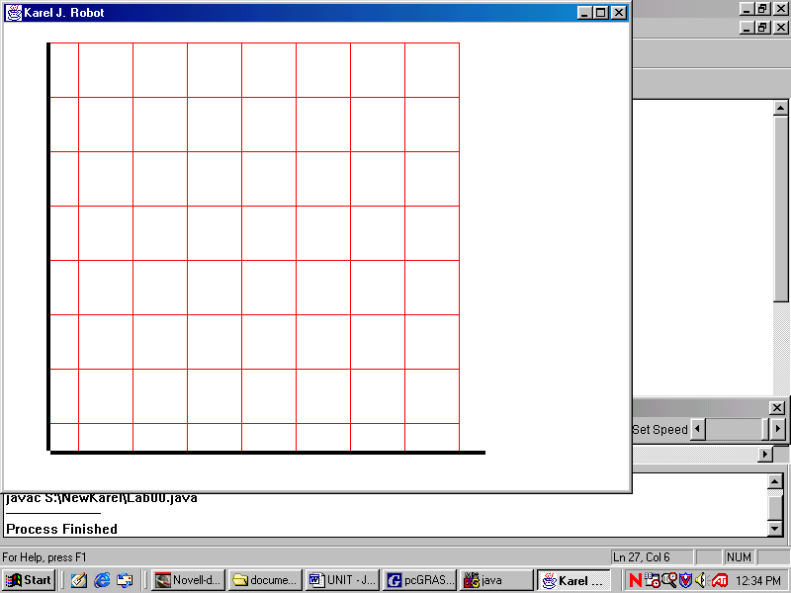

**3) Mark the following points A(1, 1), B(6, 7), C(5, 2), D(3, 8), E(8, 1) on the robot-map shown.**

**4) What has the size of this robot-map been set to?**

8 x 8

**5) Give the command to set that size.**

Display.setSize(8, 8);

**6) Lisa is a teacher at the local high school. She needs to store some books in the storage room downstairs. Lisa takes the books from the math office to the student lounge, where eager students wait to help their teachers. Lisa gives the books to pete, who cheerfully stores the books on the smallest pile.**

**Identify the nouns in the story above**

**Identify the verbs in the story above**

**7) In objected oriented programming, nouns turn into objects/classes**

**8) In objected oriented programming, verbs turn into methods**

**9) Our Lab01 program models the story from Question #6 using robots and books. Think of other classes that could have been used instead to solve the same problem.**

Books represent beepers so we could give the latter another name but they would always remain beepers. They are not a class. Robot, however, is a class: instead of it we could have used Athlete, Carpeter, Harvester, Shifter or Swimmer, all subclasses of Robot.

**10) In terms of your new classes, what should be the fields (private data) of each class?**

The fields of each class should be the same as those of the Robot class: direction, location and number of beepers. What differs them from Robot is that they have more methods/behaviors.

**11) Thinking about your new classes, what behaviors would it be useful to have?**

It would be useful for the new classes to have the same behaviors as the Robot class in addition to the ability to turn right and that to turn around (Athlete is the perfect fit!).